Exercise: JS Basic Syntax, Conditional Statements, and Loops
Ask your questions here https://www.slido.com/ by entering the code fund-js
Submit your solutions in the SoftUni judge system at:
https://alpha.judge.softuni.org/contests/basic-syntax-conditional-statements-and-loops-exercise/1207

Ages
Write a function that determines whether based on the given age a person is: baby, child, teenager, adult, elder.
The input comes as a single number parameter. The bounders are:
- 0-2 (age) – is a baby;
- 3-13 (age) – is a child;
- 14-19 (age) – is a teenager;
- 20-65 (age) – is an adult;
- >=66 (age) – is an elder;
- In all other cases print – "out of bounds";
The output should be printed to the console.

Examples
Input | Output
20 | adult
1 | baby
100 | elder
-1 | out of bounds

- Rounding
Write a JS function that rounds numbers to a specific precision.
The input comes as two numbers. The first value is the number to be rounded and the second is the precision (significant decimal places). If the passed precision is more than 15, it should automatically be reduced to 15.
Remove trailing zeroes, if any (you can use parseFloat (number))
The output should be printed to the console. Do not print insignificant decimals.

Examples
Input | Output |  | Input | Output
3.1415926535897932384626433832795,2 | 3.14 |  | 10.5,3 | 10.5

Division
You will be given a number and you have to check whether that number is divisible by any of the following numbers: 2, 3, 6, 7, and 10. You should always take the bigger division.
If the number is divisible by both 2 and 3 it is also divisible by 6 and you should print only the division by 6. If a number is divisible by 2 it is sometimes also divisible by 10 and you should print the division by 10.
If the number is not divisible by any of the given numbers print: "Not divisible". Otherwise, print: "The number is divisible by {number}".

Examples
Input | Output
30 | The number is divisible by 10
15 | The number is divisible by 3
12 | The number is divisible by 6
1643 | Not divisible

Vacation
You are given a group of people, the type of the group, and the day of the week they are going to stay. Based on that information calculate how much they have to pay and print that price on the console. Use the table below. In each cell is the price for a single person.
The output should look like that: `Total price: {price}`. The price should be formatted to the second decimal point.
 | Friday | Saturday | Sunday
Students | 8.45 | 9.80 | 10.46
Business | 10.90 | 15.60 | 16
Regular | 15 | 20 | 22.50

There are also discounts based on some conditions:
- Students – if the group is bigger than or equal to 30 people you should reduce the total price by 15%
- Business – if the group is bigger than or equal to 100 people 10 of them can stay for free
- Regular – if the group is bigger than or equal to 10 and less than or equal to 20 reduce the total price by 5%
Note: You should reduce the prices in that EXACT order.

Examples
Input | Output
30,  "Students",  "Sunday" | Total price: 266.73
40,  "Regular",  "Saturday" | Total price: 800.00

Leap Year
Write a JS function to check whether a year is a leap. Leap years are either divisible by 4 but not by 100 or are divisible by 400. The output should be following:
- If the year is a leap, print: "yes"
- Otherwise, print: "no"

Examples
Input | Output
1984 | yes
2003 | no
4 | yes

Print and Sum
Write a function that displays numbers from given start to given end and their sum. The input comes as two number parameters. Print the result like the examples below:

Examples
Input | Output
5, 10 | 5 6 7 8 9 10  Sum: 45
0, 26 | 0 1 2 … 26  Sum: 351
50, 60 | 50 51 52 53 54 55 56 57 58 59 60  Sum: 605

Triangle of Numbers
Write a function, which receives a single number – n, and prints a triangle from 1 to n as in the examples.

Constraints
- n will be in the interval [1...20].

Examples
Input | Output |  | Input | Output |  | Input | Output
3 | 1  2 2  3 3 3 |  | 5 | 1  2 2  3 3 3  4 4 4 4  5 5 5 5 5 |  | 6 | 1  2 2  3 3 3  4 4 4 4  5 5 5 5 5  6 6 6 6 6 6

Multiplication Table
You will receive a number as a parameter. Print the 10 times table for this number. See the examples below for more information.

Output
Print every row of the table in the following format:
{number} X {times} = {product}

Constraints
- The number will be an integer will be in the interval [1…100].

Examples
Input | Output |  | Input | Output
5 | 5 X 1 = 5  5 X 2 = 10  5 X 3 = 15  5 X 4 = 20  5 X 5 = 25  5 X 6 = 30  5 X 7 = 35  5 X 8 = 40  5 X 9 = 45  5 X 10 = 50 |  | 2 | 2 X 1 = 2  2 X 2 = 4  2 X 3 = 6  2 X 4 = 8  2 X 5 = 10  2 X 6 = 12  2 X 7 = 14  2 X 8 = 16  2 X 9 = 18  2 X 10 = 20

* Login
You will be given a string representing a username. The correct password will be that username reversed. Until you receive the correct password print on the console: "Incorrect password. Try again.". When you receive the correct password print: "User {username} logged in."
However, on the fourth try if the password is still not correct print: "User {username} blocked!" and end the program.
The input comes as an array of strings - the first string represents username and each subsequent string is a password.

Examples
Input | Output
['Acer','login','go','let me in','recA'] | Incorrect password. Try again.  Incorrect password. Try again.  Incorrect password. Try again.  User Acer logged in.
['momo','omom'] | User momo logged in.
['sunny','rainy','cloudy','sunny','not sunny'] | Incorrect password. Try again.  Incorrect password. Try again.  Incorrect password. Try again.  User sunny blocked!

- * The Pyramid of King Djoser
Write a JS program that calculates how much resources will be required for the construction of a pyramid. It is made out of stone, marble, lapis lazuli, and gold. Your program will receive an integer that will be the base width and length of the pyramid and an increment that is the height of each step. The bulk is made out of stone, while the outer layer is made out of marble. Every fifth step’s outer layer is made out of lapis lazuli instead of marble. The final step is made out of gold.
The pyramid is built with 1x1 blocks with a height equal to the given increment. The first step of the pyramid has a width and length equal to the given base and every next step is reduced by 2 blocks (1 from each side). The height of every step equals the given increment. See the drawing for an example. White steps are covered in marble, blue steps are covered in lapis lazuli (every fifth layer from the bottom), and yellow steps are made entirely out of gold (top-most step).
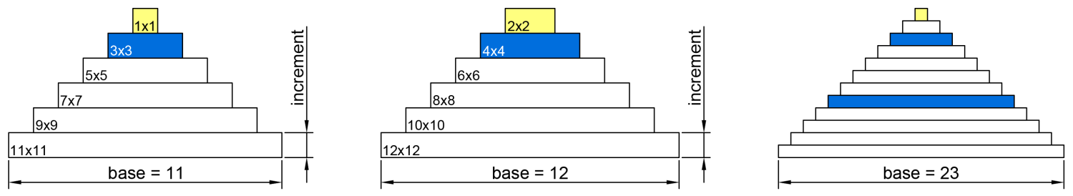
Since the outer layer of each step is made of decorative material, to calculate the required stone for one step, reduce the width and length by 2 blocks (one from each side), find its area, and multiply it by the increment. The rest of the step is made out of lapis lazuli for every fifth step from the bottom and marble for all other steps. To find the amount needed, you may, for example, find its perimeter and reduce it by 4 (to compensate for the overlapping corners), and multiply the result by the increment. See the drawing for details (grey is stone, white is decoration).
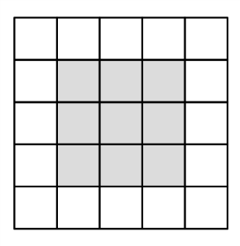 | 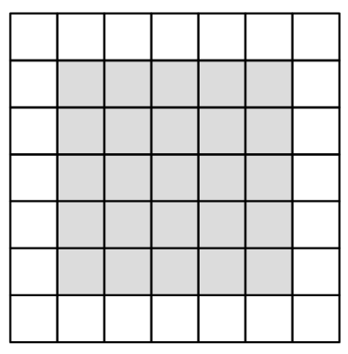 | 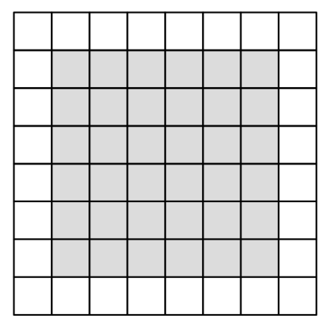
5x5 step  Stone required – 9 x increment  Marble required– 16 x increment | 7x7 step  Stone required – 25 x increment  Marble required – 24 x increment | 8x8 step  Stone required – 36 x increment  Marble required – 28 x increment

Note the top-most layer is made entirely out of gold, with a height equal to the given increment. See the examples for complete calculations.

Input
You will receive two number parameters base and increment.

Output
Print on the console on separate lines the total required amounts of each material rounded up and the final height of the pyramid rounded down, as shown in the examples.

Constraints
- The base will always be an integer greater than zero
- The increment will always be a number greater than zero
- Number.MAX_SAFE_INTEGER will never be exceeded for any of the calculations

Examples
Input | Output | Explanation
11,  1 | Stone required: 165  Marble required: 112  Lapis Lazuli required: 8  Gold required: 1  Final pyramid height: 6 | Step | Size | Stone | Marble | Lapis | Gold
 |  | 1st | 11x11 | 81 | 40 | - | -
 |  | 2nd | 9x9 | 49 | 32 | - | -
 |  | 3rd | 7x7 | 25 | 24 | - | -
 |  | 4th | 5x5 | 9 | 16 | - | -
 |  | 5th | 3x3 | 1 | - | 8 | -
 |  | 6th | 1x1 | - | - | - | 1
 |  | total | Height=6 | 165 | 112 | 8 | 1

Input | Output | Explanation
11,  0.75 | Stone required: 124  Marble required: 84  Lapis Lazuli required: 6  Gold required: 1  Final pyramid height: 4 | Total stone is 81*0.75+49*0.75+25*0.75+9*0.75+1*0.75 = 123.75, we round up to 124.  Total marble is 40*0.75+32*0.75+24*0.75+16*0.75=84.  Total lapis lazuli is 8*0.75=6.  Total gold is 1*0.75=0.75, we round up to 1.  Total height is 4.5 (6 steps times 0.75), we round down to 4.

Input | Output |  | Input | Output
12,  1 | Stone required: 220  Marble required: 128  Lapis Lazuli required: 12  Gold required: 4  Final pyramid height: 6 |  | 23,  0.5 | Stone required: 886  Marble required: 228  Lapis Lazuli required: 36  Gold required: 1  Final pyramid height: 6

* Bitcoin "Mining"
Write a JavaScript program that calculates the total amount of bitcoins you purchased with the gold you mined during your shift at the mine. Your shift consists of a certain number of days where you mine an amount of gold in grams. Your program will receive an array with the amount of gold you mined each day, where the first day of your shift is the first index of the array. Also, someone was stealing every third day from the start of your shift 30% from the mined gold for this day. You need to check, which day you have enough money to buy your first bitcoin. For the different exchanges use these prices:
1 Bitcoin | 11949.16 lv.
1 g of gold | 67.51 lv.

Input
You will receive an array of numbers, representing your shift at the mine.

Output
Print on the console these lines in the following formats:
- First-line prints the total amount of bought bitcoins:
`Bought bitcoins: {count}`
- Second-line prints which day you bought your first bitcoin:
`Day of the first purchased bitcoin: {day}`
In case you did not purchase any bitcoins, do not print the second line.
- Third-line prints the amount of money that’s left after the bitcoin purchases rounded by the second digit after the decimal point:
`Left money: {money} lv.`

Constraints
- The input array may contain up to 1,000 elements
- The numbers in the array are in the range [0.01..5,000.00] inclusive
- Allowed time/memory: 100ms/16MB

Examples
Input | Output
[100, 200, 300] | Bought bitcoins: 2  Day of the first purchased bitcoin: 2  Left money: 10531.78 lv.

Scroll down to see the explanation for the first example and more examples.
Explanation
Day 1 – you dig up 100 g of gold then exchange it for 6751.00 lv.

Day 2 – you dig up 200 g of gold then exchange it for 13,502.00 lv. and the total amount of money is 20,253.00 lv. Then you buy 1 Bitcoin which leaves you with 8,303.84 lv. Also, this purchase is the first day you bought bitcoin.

Day 3 – you dig up 300 g of gold but then 30% of it is stolen and your gold drops to 210 g which you exchange for 14,177.10 lv. making your total amount of money 22,480.94 lv. Then you buy 1 Bitcoin making the final amount of money that you have left with 10,531.78 lv. with 2 bought Bitcoins.

Input | Output |  | Input | Output
[50, 100] | Bought bitcoins: 0  Money left: 10126.50 lv. |  | [3124.15, 504.212, 2511.124] | Bought bitcoins: 30  Day of the first purchased bitcoin: 1  Money left: 5144.11 lv.

